Receipt and Invoice Digitizer

Milestone 3 – Dashboard & Reporting

TEAM - A

Team Members:
• Harini Kaveti
• Abhay Maurya
• Vaibhavi Vernekar
• Pattem Dharmika

1. Problem Statement:
Although invoice data was successfully extracted and stored in the database, critical gaps remained in data presentation and business insights. There was no centralized dashboard, no visual spending trends, no structured monthly summaries, and limited reporting/export functionality.

2. Milestone- 3 Objectives:
- Build an interactive Stream lit dashboard for centralized data access.
- Implement monthly spending analytics and KPI calculations.
- Add CSV, Excel, and PDF export functionality.
- Create vendor and item-level business insights.
- Provide a clean, responsive, and user-friendly interface.

3. Team Roles & Responsibilities:

Harini Kaveti – Analytics Module
- Designing analytics logic
- Monthly spending calculations
- Vendor and item statistics
- Data aggregation and trend analysis
- KPI calculation and month-over-month comparison

Abhay Maurya – Visualization Module
- Designing and implementing charts
- Creating Plotly visualizations
- Ensuring clarity and readability
- Applying consistent design themes
- Building reusable chart functions

Vaibhavi Vernekar – Dashboard & UI
- Structuring dashboard layout
- Implementing filters and user controls
- Ensuring responsive UI design
- Integrating backend with frontend
- Displaying KPIs and insights

Pattem Dharmika – Reporting & Export
- Implementing CSV, Excel, and PDF exports
- Structuring summary and detailed reports
- Ensuring export accuracy
- Handling data validation and error management
- Maintaining secure data export process

4. Module Description:

1. Analytics Module
The Analytics Module is responsible for processing structured invoice data and generating meaningful financial insights.
- Calculates key performance indicators (KPIs) such as:
  - Total Spend
  - Average Spend per Month
  - Total Number of Transactions
  - Unique Vendor Count
  - Average Transaction Value

2. Visualization Module
The Visualization Module converts processed data into interactive graphical representations.
- Generates monthly spending trend line charts.
- Displays vendor-wise and category-wise distribution using bar and pie charts.
- Creates payment method analysis charts.
- Shows transaction frequency using histograms.
- Presents item-level insights for detailed financial breakdown.
- Uses Plotly to enable zooming, hovering, and interactive exploration.
- Maintains consistent theme, layout alignment, and readable chart labels.
- Supports responsive resizing for better user experience.

3. Dashboard & UI
The Dashboard & UI module provides a centralized and user-friendly interface for interaction.
- Integrates analytics results and visualizations into a single dashboard view.
- Displays KPI cards for quick summary insights.
- Provides filters such as date range, vendor selection, and category filtering.
- Allows real-time updates when filters are applied.
- Ensures clean layout with proper spacing and structured sections.
- Connects frontend components with backend processing logic.
- Designed using Streamlit for fast deployment and easy maintainability.

4. Reporting & Export Module
The Reporting & Export Module manages structured report generation and secure data downloads.
- Supports exporting financial data in:
  - CSV format
  - Excel format
  - PDF format
- Provides both Summary Reports (aggregated KPIs) and Detailed Reports (transaction-level data).
- Ensures correct formatting and data consistency in exported files.

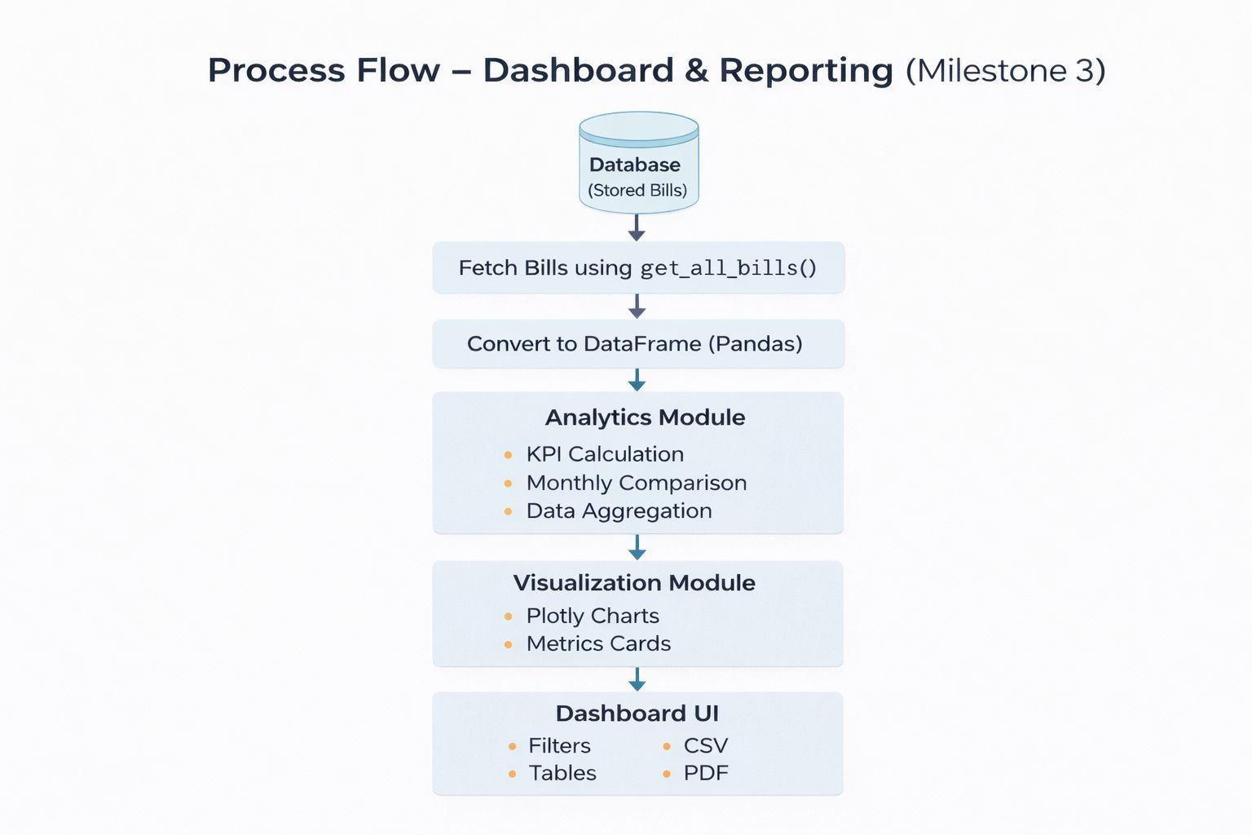
5. Process Flow:

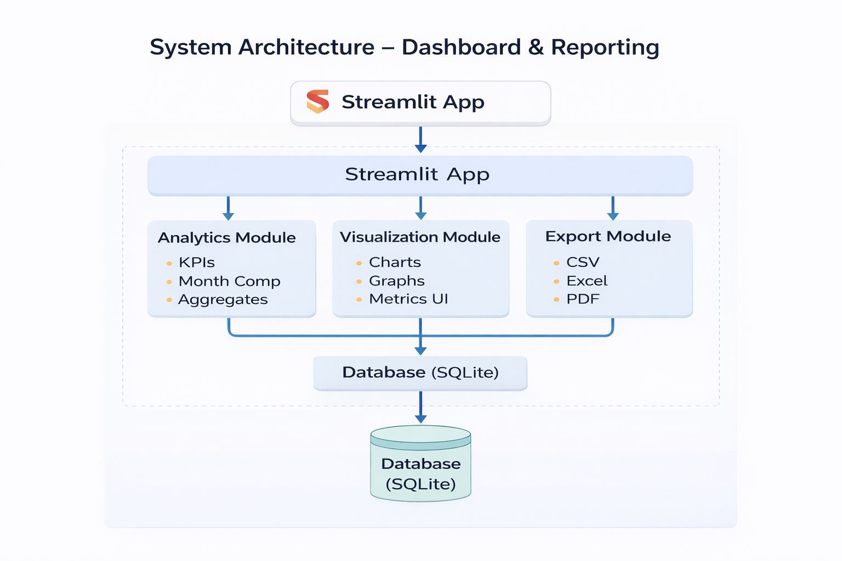
6. System Architecture:

7. Development Timeline (Weeks 5–6):

Week 5 – Planning & Structure
- Designed dashboard layout and structure
- Created analytics logic
- Defined data flow and processing steps
- Planned visualization and export features

Week 6 – Development & Testing
- Implemented KPIs
- Added export functionality (CSV/Excel/PDF)
- Integrated frontend and backend
- Performed testing and debugging
- Final validation and deployment preparation

8. Conclusion:

The successful completion of Milestone 3 marks the transformation of the Receipt and Invoice Digitizer system from a data extraction tool into a complete financial analytics platform. The implementation of a centralized Streamlit dashboard enabled structured data visualization, real-time KPI monitoring, and improved decision-making support.
The integration of analytics logic, interactive Plotly visualizations, and secure export functionality (CSV, Excel, and PDF) ensures that users can not only view insights but also generate professional reports for business use. The modular three-layer architecture enhances scalability, maintainability, and performance.

9. Final Output:
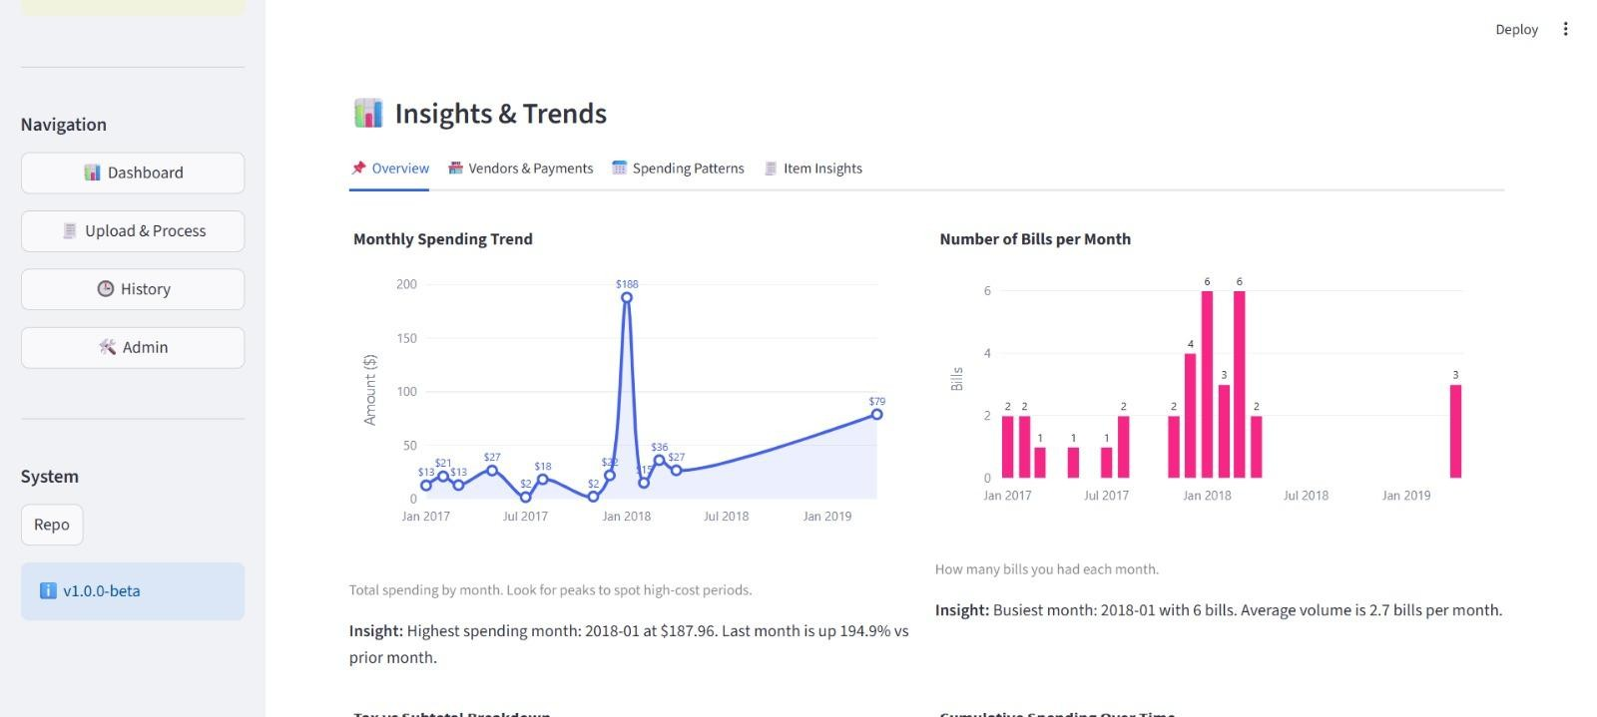
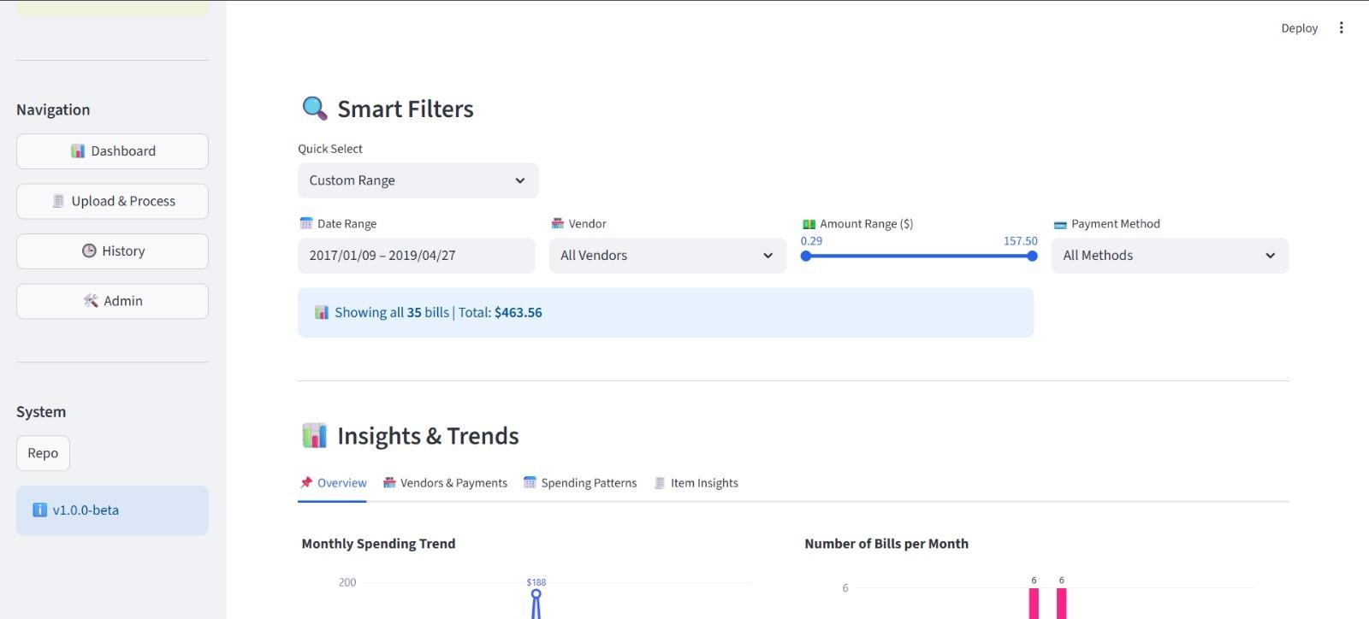
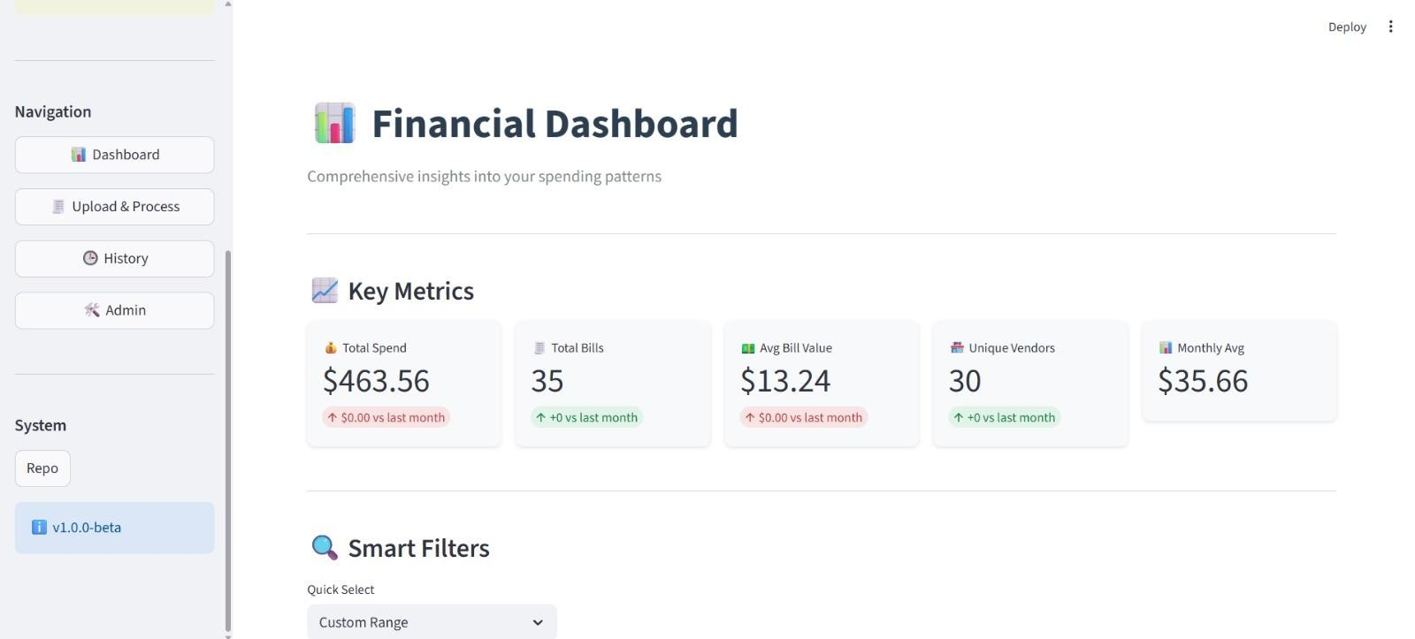

Milestone 4 – Polishing & Integration

TEAM - A

Team Members:
- Abhay Maurya
- Pattem Dharmika
- Harini Kaveti
- Vaibhavi Vernekar

1. Problem Statement:

In the previous milestones, the system successfully implemented OCR extraction, data storage, and dashboard analytics. However, three key challenges remained:
- Extraction accuracy varied depending on vendor format.
- Dashboard lacked advanced search flexibility for large datasets.
- Data retrieval performance could degrade as records increased.
To address these issues, Milestone 4 focused on improving extraction reliability, enhancing dashboard interactivity, and optimizing database performance.

2. Milestone – 4 Objectives:

Milestone 4 focused on the following objectives:
• Improve extraction accuracy using template-based parsing
• Add advanced search and filter capabilities in dashboard
• Optimize database queries and reporting performance
• Integrate AI-powered financial insight generation

3. Team Roles & Responsibilities:

1. Pattem Dharmika - Template-Based Parsing
Responsible for improving vendor-specific extraction accuracy using deterministic templates.

2. Abhay Maurya - AI Insight Generation
Responsible for generating intelligent financial insights using Google Gemini AI.

3. Vaibhavi Vernekar - Search & Filter System
Responsible for implementing dynamic dashboard filtering and SQL-based filtering logic.

4. Harini Kaveti - Database Optimization & Query Performance
Responsible for improving query efficiency, reducing unnecessary data loading, and optimizing report generation.

4. Module Description:

1. Template-Based Parsing Module
This module enables dynamic filtering of bills in the dashboard using:
• Date range (preset + custom)
• Vendor filter
• Amount range slider
• Payment method filter
Filtering is performed using SQL instead of Pandas to improve performance.
Additional Points:
• Reduces dashboard loading time
• Enables real-time data exploration
Purpose: Allow users to quickly explore financial records.
Result: Faster dashboard response and improved user experience.

2. AI Insight Generation Module
This module uses Google Gemini AI to generate intelligent financial summaries based on dashboard analytics.
It builds structured prompts and produces meaningful explanations beyond numeric charts.
Additional Points:
• Converts numerical trends into natural language insights
• Enhances decision-making with contextual summaries
Purpose: Provide high-level financial interpretation.
Result: Users receive smart insights instead of just raw data.

3. Search & Filter System
This module enables dynamic filtering of bills in the dashboard using:
• Date range (preset + custom)
• Vendor filter
• Amount range slider
• Payment method filter
Filtering is performed using SQL instead of Pandas to improve performance.
Additional Points:
• Reduces dashboard loading time
• Enables real-time data exploration
Purpose: Allow users to quickly explore financial records.
Result: Faster dashboard response and improved user experience.

4. Database Optimization & Query Performance
This module improves performance by shifting filtering and aggregation logic from Pandas to SQL.
Key improvements:
• SQL-based filtering
• SQL monthly aggregation
• Database indexing
• Reduced memory usage
Additional Points:
• Improves scalability for large datasets
• Minimizes unnecessary data processing in the application layer
Purpose: Improve scalability and query efficiency.
Result: Faster reports and optimized dashboard performance.

5. Process Flow:

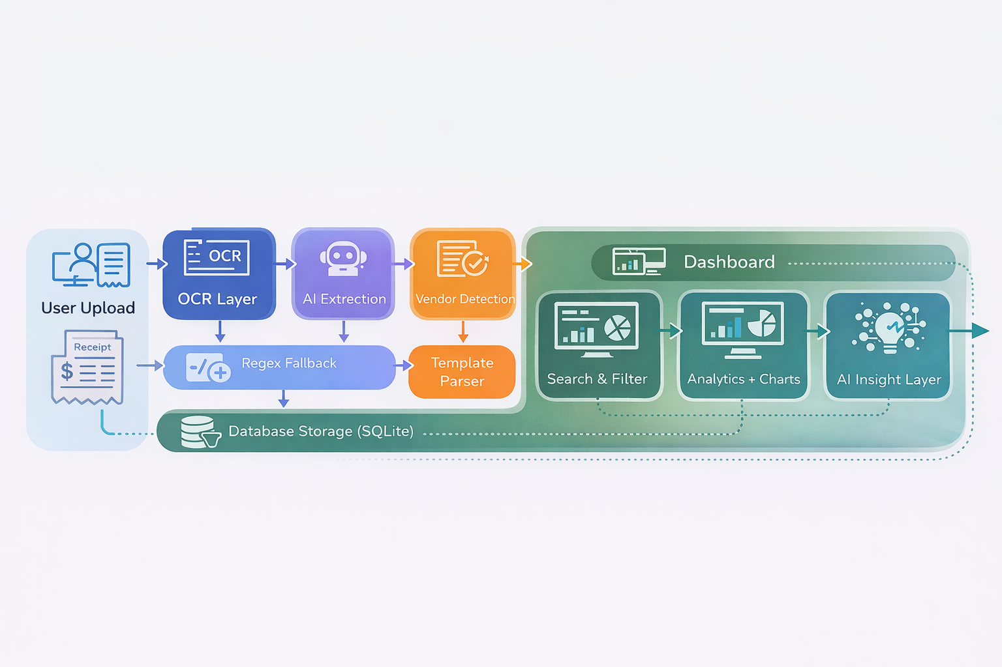

6. System Architecture:

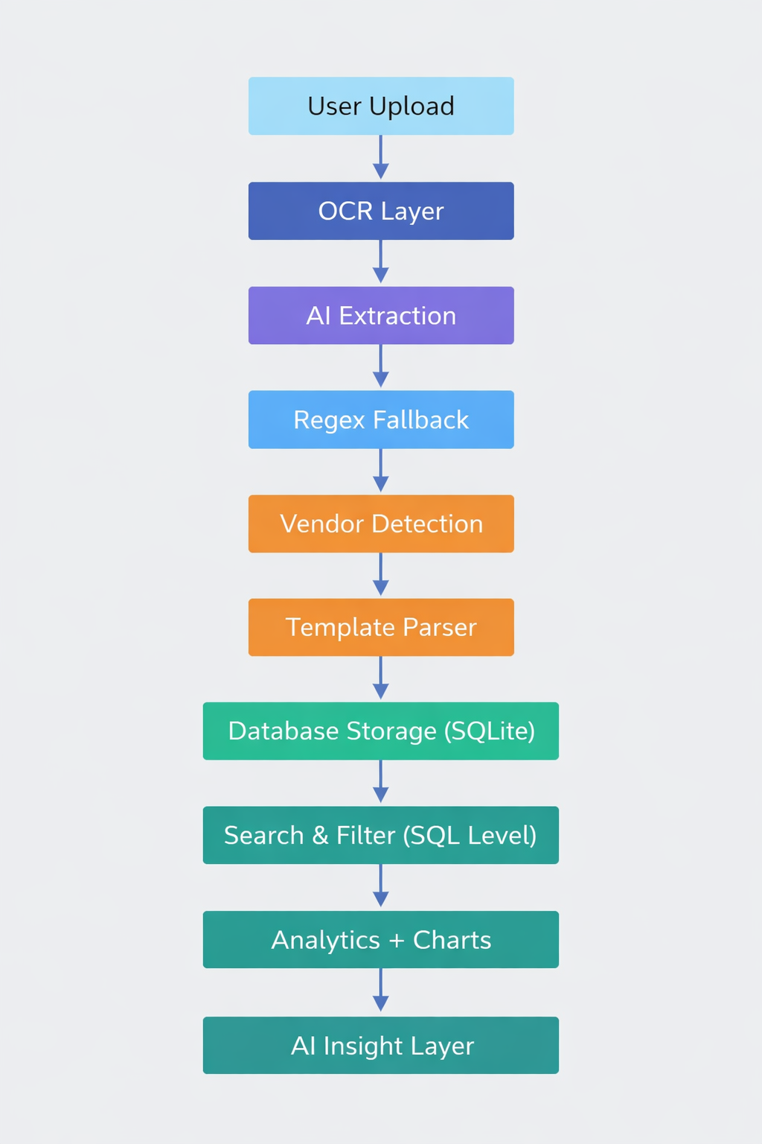

7. Development Timeline (Weeks 7–8):

Week 7:
• Template parsing integration
• SQL filter implementation
• AI insight integration
Week 8:
• Query optimization
• Indexing
• Performance testing
• Final integration & review

8. Conclusion:

Milestone 4 successfully enhanced the system by:
• Improving extraction accuracy using vendor-based templates
• Implementing SQL-based search and filter for better performance
• Optimizing database queries and reports
• Integrating AI-powered intelligent financial insights
The system is now more reliable, scalable, and production-ready.

9. Final Output

After Milestone 4:
✅ Higher extraction accuracy
✅ Faster dashboard filtering
✅ Efficient query execution
✅ AI-powered financial insights
✅ Scalable architecture
✅ Improved user interaction

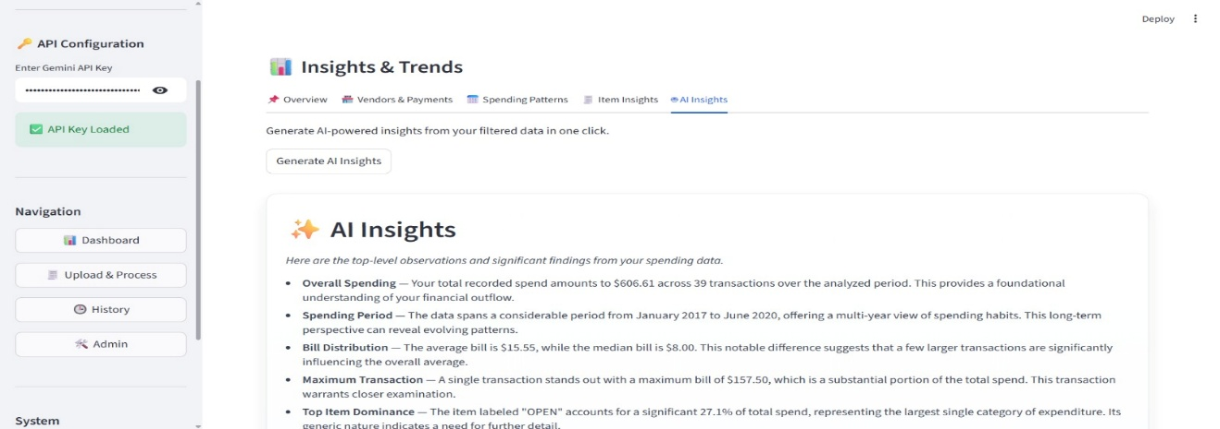

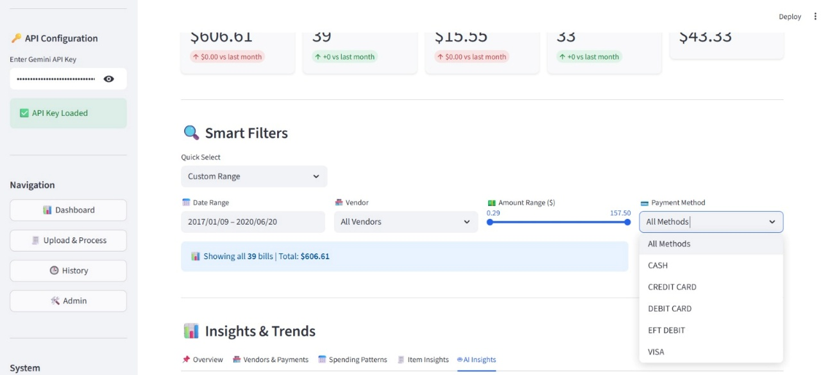

12. References

📘 Books
1. J. Friedl, Mastering Regular Expressions, 3rd ed. O’Reilly Media, 2006.
2. A. Silberschatz, H. F. Korth and S. Sudarshan, Database System Concepts, 6th ed. McGraw-Hill, 2010.
3. C. M. Bishop, Pattern Recognition and Machine Learning. Springer, 2006.

📄 Research Papers
4. M. Sarawagi, “Information extraction,” Foundations and Trends in Databases, vol. 1, no. 3, pp. 261–377, 2008.
5. A. McCallum, D. Freitag and F. Pereira, “Maximum entropy Markov models for information extraction and segmentation,” Proceedings of ICML, pp. 591–598, 2000.

🌐 Online Resources
6. SQLite Documentation, “SQLite Documentation,” SQLite. [Online]. Available: https://www.sqlite.org/docs.html. [Accessed: 17-Feb-2026].
7. Streamlit Team, “Streamlit Documentation,” Streamlit. [Online]. Available: https://docs.streamlit.io. [Accessed: 17-Feb-2026].
8. Plotly Technologies Inc., “Plotly Python Graphing Library,” Plotly. [Online]. Available: https://plotly.com/python/. [Accessed: 17-Feb-2026].
9. Python Software Foundation, “re — Regular expression operations,” Python Documentation. [Online]. Available: https://docs.python.org/3/library/re.html. [Accessed: 17-Feb-2026].
10. Google Developers, “Gemini API Documentation,” Google. [Online]. Available: https://developers.google.com/gemini. [Accessed: 17-Feb-2026].

